**Banking Data Analysis in SQL**

***Name-PRANAY HALDER***

1. List all customers who haven't made transactions in the last year.

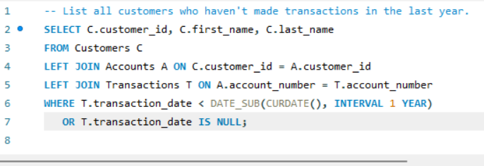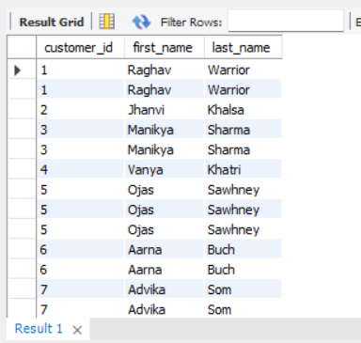

2. Summarize the total transaction amount per account per month.

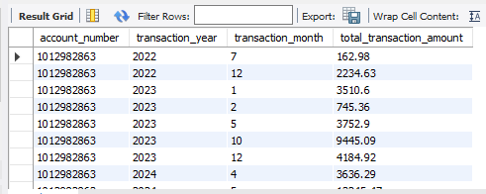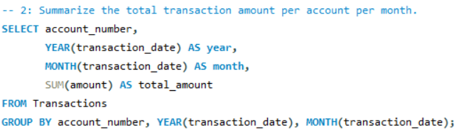

3. Rank branches based on the total amount of deposits made in the last quarter.

3: Rank branches based on the total amount of deposits made in the last quarter.

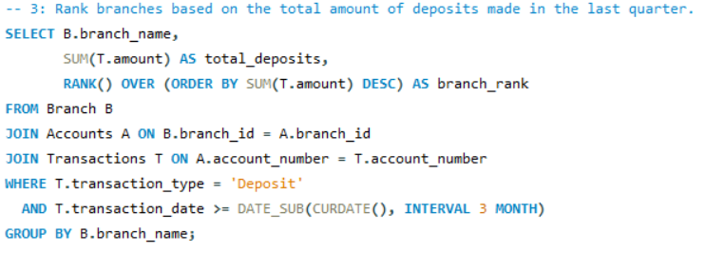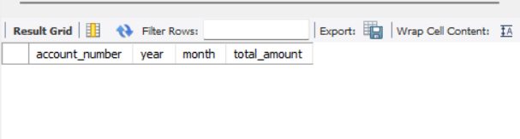

4. Find the name of the customer who has deposited the highest amount.

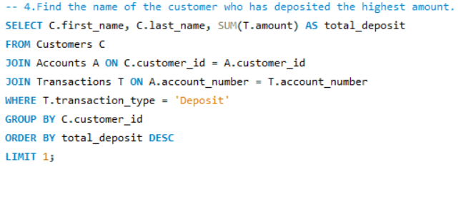

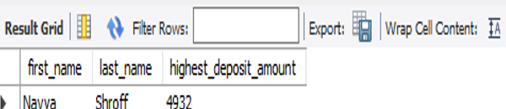

5: Identify any accounts that have made more than two transactions in a single day, which could indicate fraudulent activity. How  
can you verify any fraudulent transaction?

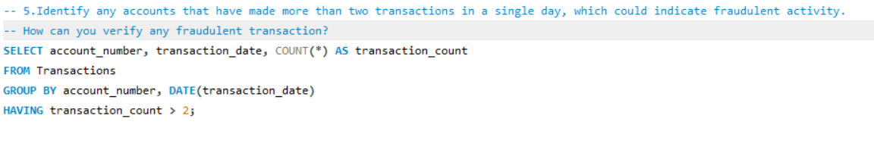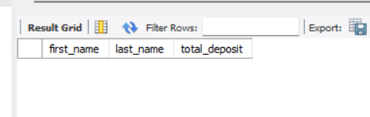

6. Calculate the average number of transactions per customer per account per month over the last year.

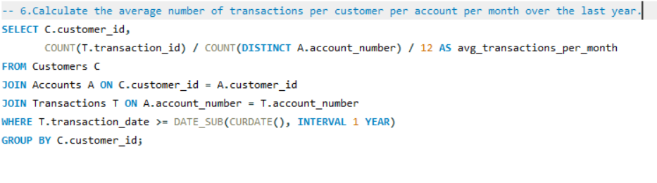

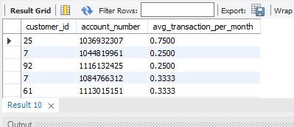

7: Write a query to find the daily transaction volume (total amount of all transactions) for the past month.

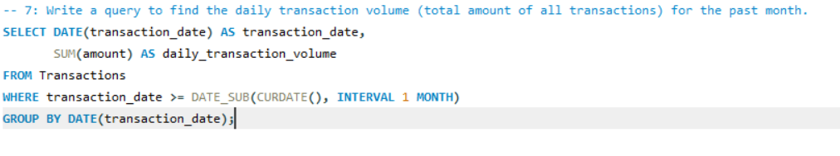

8. Calculate the total transaction amount performed by each age group in the past year. (Age groups: 0-17, 18-30, 31-60, 60+)

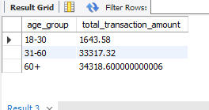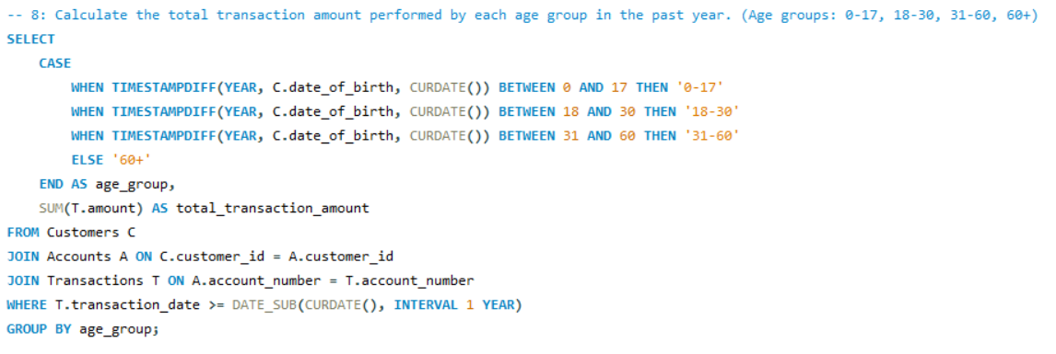

9: Find the branch with the highest average account balance.

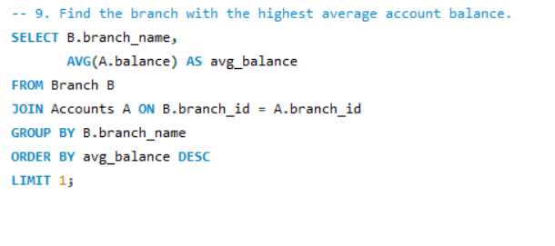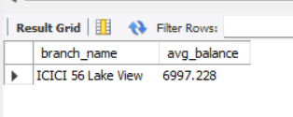

10. Calculate the average balance per customer at the end of each month in the last year.

